Per setup
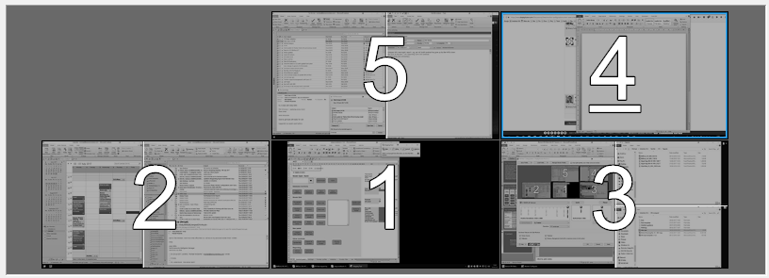
Windows
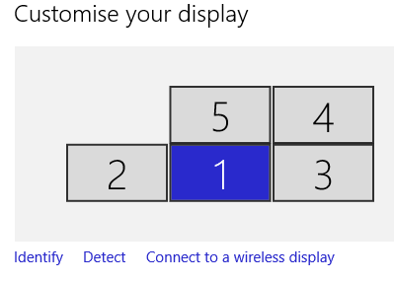
Load profile
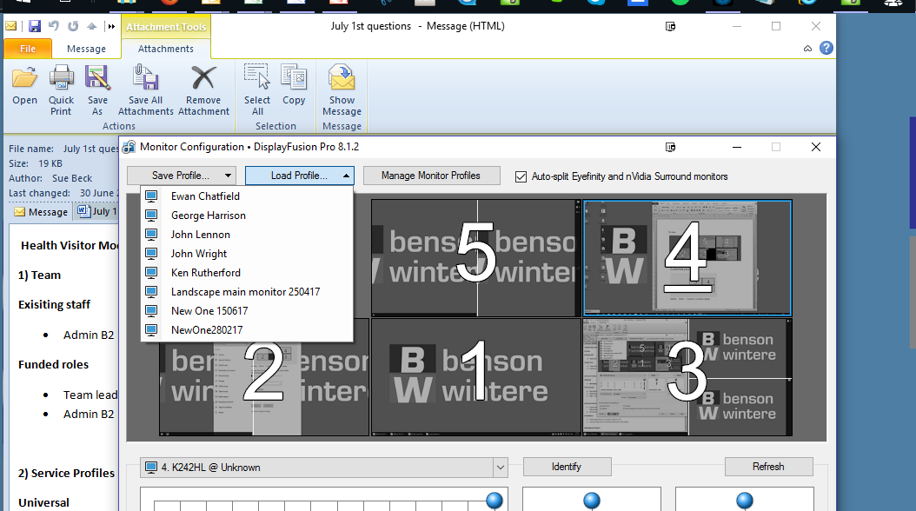

Now you can see this issue here! All the screens are mixed up. You can imagine the mouse now doesn’t move in the original grid as the monitors have all changed places.


